Please ensure you complete the Purple GMS (General Medical services) form clearly at the do understand that not all questions on our registration forms are applicable to all patients. However, it is important we use the registration process to capture as much information as possible. This is to ensure that we are offering you the best standard of care and can signpost patients who may need extra support at the point of registration. Please complete the registration forms to the best of your knowledge with as much information as possible.
Patient name (BLOCK CAPITALS): Date of birth (BLOCK CAPITALS):
Consent for email correspondence Do you consent to us contacting you by email?
Yes No
Consent for SMS messages Do you consent to us contacting you by SMS messages?
Yes No
Email Address:
TEL No (Mobile):
TEL No (work):
TEL No (Home):
Have you been registered with our GP Practice before? Yes No
If you have previously been de-registered under our zero-tolerance scheme you must not register with our practice, without first writing to the Practice Manager with your request. If the practice declines your request to register, they will inform you in writing of the decision. The practice has a right to remove your registration at their discretion at any time if you have previously been removed from our list for abusive behaviour and not informed them at the point of re-registering

Your Address and postcode:

NEXT OF KIN
Name Address (including postcode):

Contact number:
Your relationship:

1

SUMMARY CARE RECORD
Your records will automatically be coded for an Enhanced Summary Care Record. If you do not want a summary care record, please ask at reception for an OPT out form and tick here
Your Summary Care Record is a short summary of your GP medical records. It tells other health and care staff who care for you about the medicines you take and your allergies. It means they can give you better care if you need health care away from your usual doctor's surgery: for example, in an emergency, when you're on holiday, when your surgery is closed, at out-patient clinics or when you visit a pharmacy.
National Data Opt Out (Type 2) can be done via the following routes:
- https://digital.nhs.uk/services/national-data-opt-out
- Post
- Using the NHS App

THIRD PARTY ACCESS
In the Practice we aim to provide you with the highest quality of healthcare. To do this we must keep records about you, your health, and the care we have provided or plan to provide to you. Everyone working for the NHS has a legal duty to keep information about you confidential. If you would like a family member or carer to have access to your medical records on your behalf. We need to keep their contact details on your records.
The person you nominate must be happy to have their details recorded in your medical records. If you wish to nominate someone for this reason, please provide us with their details and sign below that you consent to this.
Name of nominated individual………………………………………..
Your signature…………………………………………….. Date…………………………..

2
New Patient Questionnaire

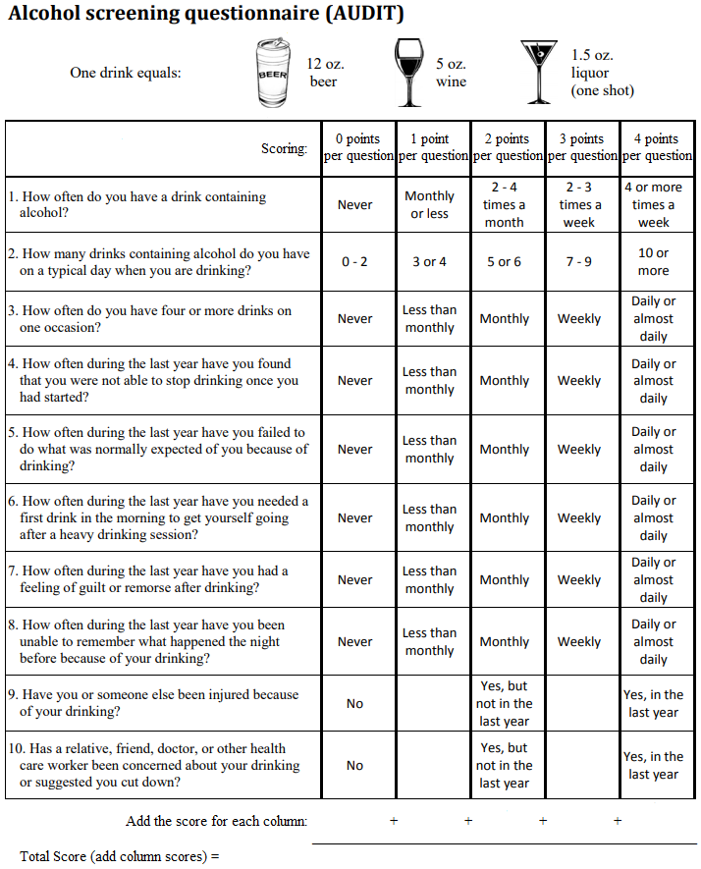
Ethnicity
Do you require an interpreter? Yes No
Other (Please state) …………………………………

English
First spoken Language:

Caribbean African Other Black Mixed Other
Other white
Black or British Black
British
Irish
Asian or British Asian
Other Asian
Chinese
Bangladeshi
Pakistani
Indian

Lifestyle

Do you smoke? YES/NO/EX-SMOKER How Many per day?
Weight:
Height:

Communication Needs
If you require a different communication method such as an Interpreter, alternative language leaflets, Easy Read leaflets or a Sign language interpreter please state in the space below so we can fulfil your needs the best we can.
Interpreter
Sign Language
Easy Read
Other

If other please state here:

3

4

Consent
I consent to the practice contacting me by text message and/or email message for the purposes of health promotion and for appointment reminders.
I acknowledge that appointment reminders by text and/or email are an additional service and that these may not take place on all/or on any occasion and that the responsibility of attending appointments or cancelling them still rests with me. I can cancel the text and/or email message facility at any time.
Text messages are generated using a secure facility however I understand that they are sent over a public network onto a personal telephone and as such may not be secure, however the practice will not transmit any information which would enable an individual patient to be identified.
I agree to advise the practice if my email address changes and if my mobile telephone number changes or if this is no longer in my possession.
The practice does not share mobile phone contact details or email addresses with any external non-NHS organisation.
Your medical records may be used for financial or clinical audit, post payment verification checks, medical research, or education purposes.
Date
Signature

5

